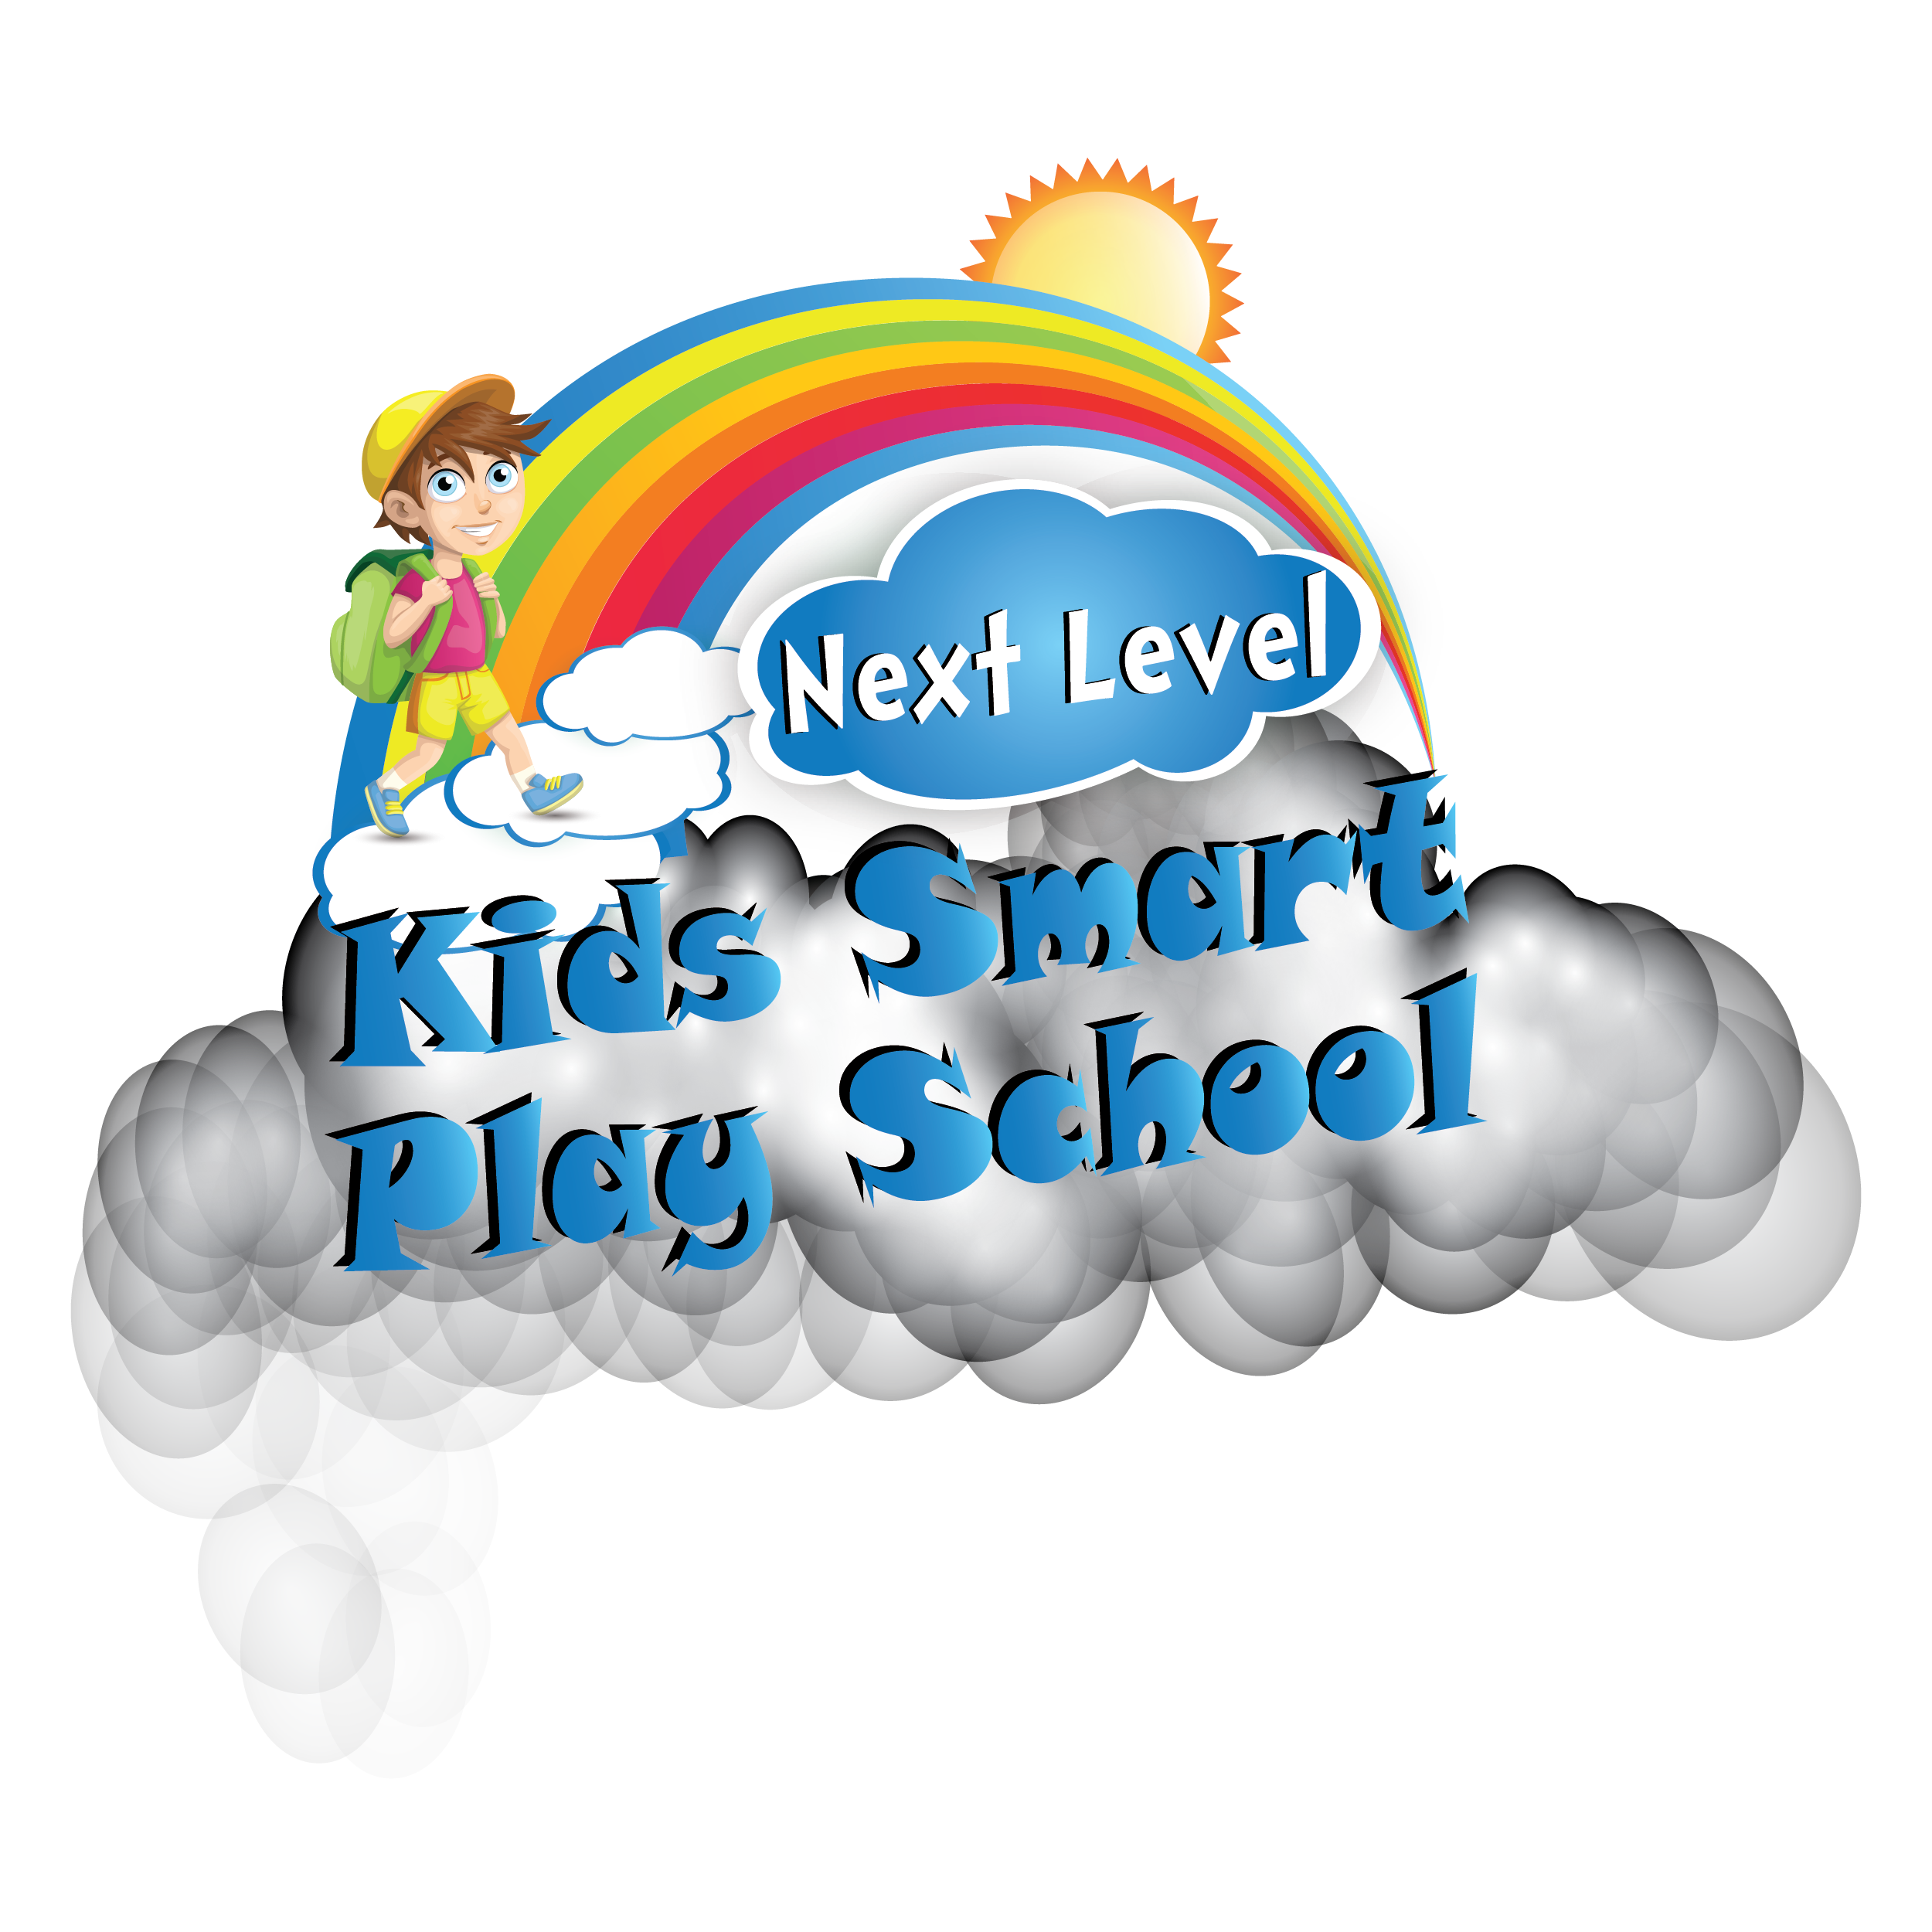
NEXT LEVEL KIDS SMART PLAY SCHOOL
No.21/11, AlaguMeenal Complex,
Subramaniapuram 1st Street South,
College Road, Karaikudi – 630002.
Contact No: 9444607733.
Email id: ganapathynlea@gmail.com
Web :www.nextlevelsmartacademy.com

NEXT LEVEL KIDS SMART PLAY SCHOOL FANCY DRESS COMPETITION- 2019
REGISTRATION FORM Appl.No: NLFDC_______

ACADAMIC YEAR: DATE: _____/_____/20_____

CHILD’S NAME :
DATE OF BIRTH : BLOOD GROUP:
AGE :
GENDER (Tick) Male Female
NAME OF THE CURRENT SCHOOL :

HEIGHT : WEIGHT :
RESIDENTIAL ADDRESS:

CATEGORIES(AGE):
- 1½ TO 2 ½

- 2 ½ TO 3 ½

PARENTAL DETAILS:
FATHER: MOTHER:
NAME : __________________________ __________________________
EDUCATIONAL QUALIFICATION:
__________________________ __________________________
OCCUPATION: __________________________ __________________________
MOBILE NO : __________________________ __________________________
EMAIL : __________________________ __________________________
:
* Rs 100 will be charged for this event.
* Cancellation of Registration will not be allowed. No refund shall be given.
DECLARATION
I agree to the rules and regulations and also to register my child in the Next Level Kids Smart Play School. Further I agree to allow photographic images of my child to be taken and utilized for promotional purpose by the Next Level Kids Smart Play School.
Date: ______________________
Signature of the Parent /Guardian
For Office use only:
______________________ ___________________
Signature of the staff in-charge Admission Co- ordinator

